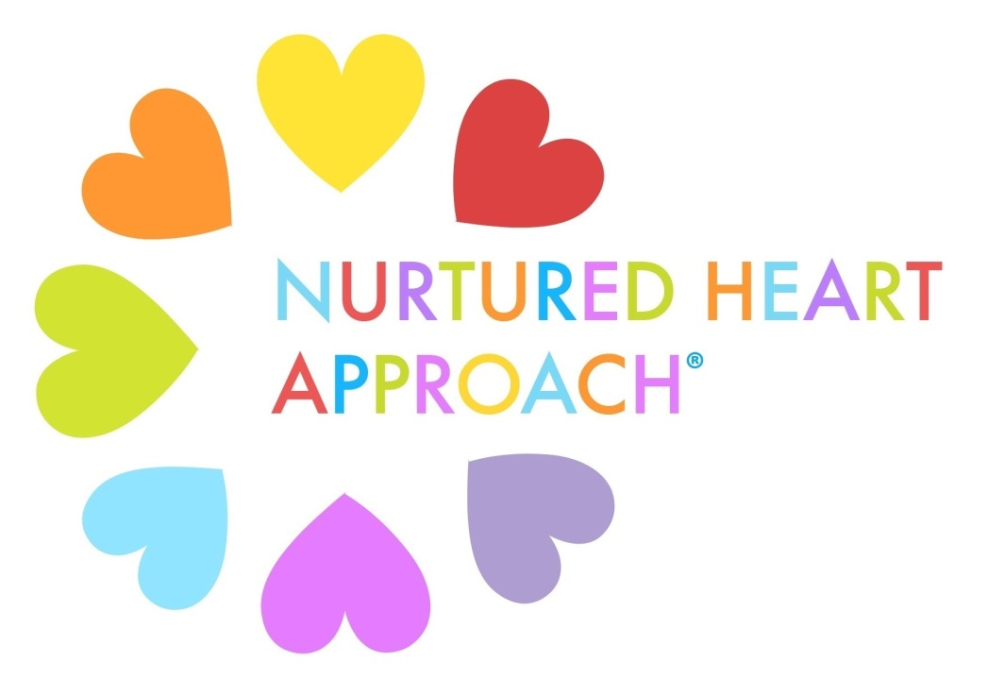

1-Hour Presentation
Participant Notes Packet

Presented by:
Melissa Niemi, M.S., CCC-SLP
Nurtured Heart Approach® Certified Trainer
Phone: 701-866-4848
Email: melissaniemi@annecenter.org

Introduction to the Nurtured Heart Approach®
__________________________________________________________
__________________________________________________________
__________________________________________________________
__________________________________________________________
__________________________________________________________

Intensity is Not the Enemy
__________________________________________________________
__________________________________________________________
__________________________________________________________
__________________________________________________________

Building Inner Wealth® / Portfolio Development
__________________________________________________________
__________________________________________________________
__________________________________________________________
__________________________________________________________
__________________________________________________________
The 3 Stands™ of NHA (an introduction)
Absolutely No! Absolutely Yes! Absolutely Clear!
__________________________________________________________
__________________________________________________________

Toys-R-Us
__________________________________________________________
__________________________________________________________
__________________________________________________________
__________________________________________________________

Stand #1: Absolutely NO! I refuse to energize negative behavior. Rather than react with elevated energy, attention, and relationship to disruptions and outbursts that distract children from their greatness, I will strive to neutralize negative behavior through immediate, concrete, and uncharged responses consistent with the harmonious environment I am creating.
__________________________________________________________
__________________________________________________________
__________________________________________________________
Video Game Theory
__________________________________________________________
__________________________________________________________
__________________________________________________________
__________________________________________________________

Stand #2: Absolutely YES! I will relentlessly energize the positive. As much as possible, I will work immediately to identify, describe, and express appreciation for steps (large and small) a child takes in manifesting his or her positive choices and intrinsic greatness. I will actively initiate opportunities for children to be successful.
__________________________________________________________
__________________________________________________________
__________________________________________________________

New Ways of Being Positive
__________________________________________________________
__________________________________________________________
__________________________________________________________
__________________________________________________________
Build the Foundation First
__________________________________________________________
__________________________________________________________
__________________________________________________________

Stand #3: Absolutely CLEAR! I will maintain total clarity about rules that demonstrate fair and consistent boundaries.
I will consistently enforce rules and provide immediate consequences through resetting each time a rule is broken. I will recognize the child in the moment they have reset and create that next moment as an opportunity for success.
__________________________________________________________
__________________________________________________________
__________________________________________________________
__________________________________________________________

Why Traditional Time-Outs Fail
__________________________________________________________
__________________________________________________________
__________________________________________________________
__________________________________________________________
Basketball Game Analogy
__________________________________________________________
__________________________________________________________
__________________________________________________________
__________________________________________________________

Transformation: The 3 Stands™ of NHA Working Together
__________________________________________________________
__________________________________________________________
__________________________________________________________
__________________________________________________________

Additional Notes:

